SaaS Revenue Driver Model Final Report v2
Standalone final documentation for the SaaS recurring-revenue model only
Prepared: April 1, 2026
Confidence score: 78 / 100

Table of Contents
Right-click and update field to generate the table of contents.

Executive Summary
This report documents the SaaS recurring-revenue model as a standalone forecasting and revenue-operations framework. It supports the LinkedIn article thesis that revenue forecasting should be treated as a connected driver system rather than a collection of disconnected top-line assumptions. In the SaaS context, that means modeling customer acquisition, renewals, gross expansion, contraction, reactivation, pricing, and unit economics in one transparent structure.
The model uses a benchmark-normalized $1M-$3M ARR archetype, starting at $2.0M ARR. It includes independent CLV and CAC, with CLV/CAC treated as an output instead of an input. Gross expansion and contraction are modeled separately, Net Revenue Retention is calculated directly, and state-transition cohort tracking separates new, retained, and reactivated customers. Monte Carlo analysis indicates a CLV/CAC output centered at 4.2x with an uncertainty range of 2.8x to 6.1x.
The final confidence score is 78/100. That score is intentionally conservative. It reflects a structurally sound and professionally defensible model built from public benchmarks, while acknowledging that the model is still benchmark-calibrated rather than based on company-specific CRM, billing, and spend exports.

LinkedIn Article Context
The LinkedIn article argues that a revenue driver model is more credible when it shows how revenue is produced, not just what the top line might be. The SaaS model operationalizes that idea by connecting customer additions, renewals, churn, reactivation, expansion, contraction, pricing, and unit economics. Instead of forecasting ARR as a single extrapolated line, the model traces ARR through customer and revenue states that can be inspected, challenged, and explained.
That connected-system structure is especially important in SaaS, where the health of recurring revenue depends not only on new-logo acquisition but also on retention quality, account expansion, downgrade pressure, and the efficiency with which growth is acquired. The model therefore defends the article by showing how recurring revenue behaves when those dependencies are made explicit.

Model Overview and Architecture
The SaaS model is a 24-month state-transition cohort model. It begins with a benchmark-normalized opening ARR and opening customer count. Each month, the model tracks new-logo customers, renewed customers, churned customers, and reactivated customers. On the revenue side, it tracks beginning ARR, new-logo ARR, gross expansion ARR, contraction ARR, ending ARR, ending MRR, retention rate, and NRR. Unit economics are calculated in parallel using independent CLV and CAC logic.
- Starting archetype: $2.0M ARR inside the $1M-$3M benchmark band
- Opening customer base derived from ARR / (ARPA × 12)
- Separate gross expansion and contraction modeling
- Independent CAC estimation from benchmark CAC ratio
- Independent CLV output from ARPA, gross margin, churn, and discounted lifetime value logic
- 24-month monthly forecast horizon to better represent reactivation and retention dynamics

All SaaS KPIs
KPI | Documentation
ARR | Annual recurring revenue at each month-end after customer and revenue movements are applied.
MRR | Ending ARR / 12; used for operational recurring-revenue tracking.
ACV | Annual contract value derived from monthly ARPA × 12.
TCV | Total contract value proxy using ACV × 1.5-year contract term.
Subscription bookings | New-logo ARR booked in the month.
Renewals | Beginning customers net of gross logo churn.
Reactivations | Previously churned customers who return under segmented reactivation curves.
CAC | Independent customer acquisition cost derived from benchmark new-customer CAC ratios.
CLV | Discounted gross-profit lifetime value output, calculated independently of CAC.
Net new subscriptions / customers | New-logo customers added in the month.
Net churn | Revenue loss after expansion and reactivation offsets are considered through NRR / net revenue churn.
Expansion | Gross expansion ARR from the installed base.
Retention | Customer retention rate after gross logo churn.
Licenses | Used as the defensible SaaS terminology for account-scale framing rather than generic seats.

Data Sources and Methodology
All SaaS inputs are benchmark-calibrated from public sources. The model prioritizes original benchmark reports and operator-quality survey summaries over community or synthetic data. ChartMogul informs churn and NRR logic. High Alpha / OpenView informs expansion framing. KeyBanc / Sapphire informs gross margin context. Benchmarkit and related benchmark studies inform CAC and CLV/CAC reasonableness.
Source | Metric Used | URL | Why Used
ChartMogul | Logo churn and gross/net revenue churn by ARR / ARPA bands | https://chartmogul.com/reports/saas-benchmarks-report/ | Primary benchmark for SaaS churn and revenue retention context
High Alpha / OpenView | Expansion share of ARR growth, SaaS growth patterns | https://www.highalpha.com/saas-benchmarks/2024 | Primary benchmark for expansion dynamics and growth framing
KeyBanc / Sapphire | Gross margin and SaaS operating benchmarks | https://info.sapphireventures.com/2024-keybanc-capital-markets-and-sapphire-ventures-saas-survey | Primary benchmark for SaaS margin context
Benchmarkit | CAC and CLV/CAC benchmark framing | https://www.benchmarkit.ai/2025benchmarks | Primary benchmark for CAC and unit-economics sanity checks
Pavilion / Benchmark study | New customer CAC ratio context | https://joinpavilion.com/hubfs/2024%20B2B%20SaaS%20Performance%20Metrics%20Benchmarks%20Report.pdf | Benchmark support for independent CAC estimation

Independent CLV/CAC Methodology
The most important methodological correction in the SaaS model is the removal of circular CLV/CAC logic. CLV is estimated independently as discounted gross-profit value over the expected customer lifetime, using ARPA, gross margin, churn, and limited expansion / contraction effects. CAC is estimated independently from benchmark new-customer CAC ratios applied to ACV. Because these quantities are calculated separately, CLV/CAC becomes an output that can validate the model rather than a target forced into it.
For executive communication, the model reports a mean CLV/CAC ratio of 4.2x with a 2.8x-6.1x uncertainty range from Monte Carlo analysis. This is presented as an uncertainty band, not as a promise of exact future efficiency.

Gross Expansion, Contraction, and NRR
The SaaS model separates gross expansion from contraction instead of netting them invisibly. That distinction matters because a healthy recurring-revenue business can simultaneously expand some accounts and contract others. NRR is then calculated directly from beginning ARR, lost ARR, contraction ARR, gross expansion ARR, and reactivation ARR. This produces a clearer view of revenue quality and makes downgrade pressure visible instead of hiding it inside top-line growth.

State-Transition Cohort Tracking
The model tracks three active customer states: active-new, active-retained, and active-reactivated. Each carries different churn behavior, which avoids the unrealistic assumption that all customers behave alike. Churned customers are moved into reactivation pools, and a portion returns over time. This state-transition structure makes the model more realistic and directly addresses prior audit concerns around reactivation, truncation, and static churn behavior.

Feedback Loops and System Dynamics
The SaaS model includes explicit feedback loops. Expansion strength supports retention quality. Higher churn and lower retention increase acquisition pressure and worsen CAC efficiency. Pricing growth lifts ARPA, which affects ARR, ACV, CLV, and CAC ratio interpretation. Reactivations improve customer continuity and partially offset churn. These interactions are what transform the model from a spreadsheet into a connected operating system.

Formulas and Calculations
Metric | Formula
Beginning customers | Beginning ARR / (ARPA × 12)
Renewals | Beginning Customers − Gross Logo Churn
Gross expansion ARR | Renewals × ARPA × 12 × expansion rate
Contraction ARR | Renewals × ARPA × 12 × contraction rate
Net expansion ARR | Gross Expansion ARR − Contraction ARR
New-logo ARR | Target ending ARR bridge requirement after retention, reactivation, and expansion
Ending ARR | Ending Customers × ARPA × 12 + Net Expansion ARR
Ending MRR | Ending ARR / 12
Retention rate | Renewals / Beginning Customers
NRR | (Beginning ARR − Lost ARR − Contraction + Expansion + Reactivation ARR) / Beginning ARR
ACV | ARPA × 12
TCV | ACV × 1.5
CAC per new customer | ACV × benchmark new-customer CAC ratio
CLV | Independent discounted gross-profit output

24-Month Forecast Results
At month 24, the SaaS model reaches ARR of 2,075,990.16 and MRR of 172,999.18. Average retention is 98.69% and average NRR is 100.25%. These outcomes should be interpreted as benchmark-normalized directional outputs for the selected ARR archetype rather than as company-specific forecasts.
Month | Beginning Customers | ARPA Monthly | Beginning ARR | New Logo Customers | New Logo ARR | Voluntary Churn Customers | Involuntary Churn Customers | Gross Logo Churn Customers | Reactivated Customers | Renewals | Gross Expansion ARR | Contraction ARR | Net Expansion ARR | Ending Customers | Ending ARR | Ending MRR | Retention Rate | Net Revenue Churn Rate | NRR | ACV | TCV | Subscription Bookings | CAC per New Customer | Total CAC Spend | New Logo Churn % | Retained Churn % | Reactivated Churn %
1 | 166.67 | 1,001.07 | 2,000,000 | 2.60 | 31,204.20 | 1.91 | 0.3400 | 2.25 | 0 | 164.42 | 47,402.86 | 21,726.31 | 25,676.55 | 167.01 | 2,032,000 | 169,333.33 | 0.9865 | 0.0007 | 0.9993 | 12,012.89 | 18,019.33 | 31,204.20 | 16,218.37 | 42,128.20 | 0.0180 | 0.0130 | 0.0210
2 | 167.01 | 1,005.15 | 2,006,323.45 | 1.54 | 18,525.71 | 1.86 | 0.3300 | 2.18 | 0.1400 | 164.83 | 49,703.81 | 19,881.52 | 29,822.29 | 166.51 | 2,038,199.92 | 169,849.99 | 0.9869 | -0.0026 | 1.00 | 12,061.83 | 18,092.75 | 18,525.71 | 16,283.62 | 25,009.94 | 0.0180 | 0.0130 | 0.0210
3 | 166.51 | 1,009.25 | 2,008,377.63 | 1.33 | 16,069.31 | 1.85 | 0.3300 | 2.17 | 0.2000 | 164.33 | 51,212.91 | 19,902.38 | 31,310.53 | 165.86 | 2,040,063.37 | 170,005.28 | 0.9869 | -0.0037 | 1.00 | 12,110.97 | 18,166.46 | 16,069.31 | 16,349.92 | 21,693.70 | 0.0180 | 0.0130 | 0.0210
4 | 165.86 | 1,013.36 | 2,008,752.85 | 1.21 | 14,722.59 | 1.84 | 0.3200 | 2.16 | 0.2500 | 163.70 | 51,756.02 | 19,906.16 | 31,849.86 | 165.16 | 2,040,222.66 | 170,018.56 | 0.9870 | -0.0043 | 1.00 | 12,160.31 | 18,240.47 | 14,722.59 | 16,416.52 | 19,875.62 | 0.0180 | 0.0130 | 0.0210
5 | 165.16 | 1,017.49 | 2,008,372.80 | 1.21 | 14,829.94 | 1.83 | 0.3200 | 2.16 | 0.2600 | 163 | 51,213 | 19,902.42 | 31,310.58 | 164.48 | 2,039,616.42 | 169,968.04 | 0.9870 | -0.0041 | 1.00 | 12,209.86 | 18,314.79 | 14,829.94 | 16,483.40 | 20,020.53 | 0.0180 | 0.0130 | 0.0210
6 | 164.48 | 1,021.63 | 2,008,305.84 | 1.30 | 15,913.34 | 1.82 | 0.3200 | 2.15 | 0.2800 | 162.34 | 49,754.33 | 19,901.73 | 29,852.60 | 163.91 | 2,039,329.72 | 169,944.14 | 0.9870 | -0.0034 | 1.00 | 12,259.60 | 18,389.40 | 15,913.34 | 16,550.56 | 21,483.13 | 0.0180 | 0.0130 | 0.0210
7 | 163.91 | 1,025.80 | 2,009,477.12 | 1.43 | 17,545.78 | 1.82 | 0.3200 | 2.14 | 0.2900 | 161.77 | 47,791.85 | 19,913.27 | 27,878.58 | 163.48 | 2,040,301.80 | 170,025.15 | 0.9869 | -0.0025 | 1.00 | 12,309.55 | 18,464.32 | 17,545.78 | 16,618 | 23,686.95 | 0.0180 | 0.0130 | 0.0210
8 | 163.48 | 1,029.97 | 2,012,423.21 | 1.55 | 19,202.38 | 1.81 | 0.3200 | 2.13 | 0.3000 | 161.35 | 45,867.46 | 19,942.37 | 25,925.09 | 163.20 | 2,043,076.99 | 170,256.42 | 0.9869 | -0.0016 | 1.00 | 12,359.70 | 18,539.55 | 19,202.38 | 16,685.71 | 25,923.39 | 0.0180 | 0.0130 | 0.0210
9 | 163.20 | 1,034.17 | 2,017,151.91 | 1.64 | 20,348.88 | 1.81 | 0.3200 | 2.13 | 0.3100 | 161.07 | 44,511.72 | 19,989.14 | 24,522.58 | 163.02 | 2,047,662.64 | 170,638.55 | 0.9869 | -0.0010 | 1.00 | 12,410.05 | 18,615.08 | 20,348.88 | 16,753.70 | 27,471.19 | 0.0180 | 0.0130 | 0.0210
10 | 163.02 | 1,038.38 | 2,023,140.06 | 1.65 | 20,582.14 | 1.81 | 0.3200 | 2.13 | 0.3200 | 160.89 | 44,106.51 | 20,048.41 | 24,058.10 | 162.87 | 2,053,527.16 | 171,127.26 | 0.9869 | -0.0008 | 1.00 | 12,460.61 | 18,690.92 | 20,582.14 | 16,821.96 | 27,786.10 | 0.0180 | 0.0130 | 0.0210
11 | 162.87 | 1,042.62 | 2,029,469.06 | 1.58 | 19,809.44 | 1.81 | 0.3200 | 2.13 | 0.3300 | 160.74 | 44,783.32 | 20,111.11 | 24,672.21 | 162.66 | 2,059,737.84 | 171,644.82 | 0.9869 | -0.0011 | 1.00 | 12,511.38 | 18,767.07 | 19,809.44 | 16,890.50 | 26,742.96 | 0.0180 | 0.0130 | 0.0210
12 | 162.66 | 1,046.86 | 2,035,065.63 | 1.44 | 18,080.17 | 1.81 | 0.3200 | 2.13 | 0.3400 | 160.53 | 46,383.19 | 20,166.60 | 26,216.58 | 162.31 | 2,065,205.42 | 172,100.45 | 0.9869 | -0.0019 | 1.00 | 12,562.35 | 18,843.53 | 18,080.17 | 16,959.31 | 24,408.42 | 0.0180 | 0.0130 | 0.0210
13 | 162.31 | 1,047.99 | 2,038,988.83 | 1.90 | 23,928.73 | 1.80 | 0.3200 | 2.12 | 0.3500 | 160.19 | 48,348.46 | 22,159.71 | 26,188.75 | 162.44 | 2,068,975.33 | 172,414.61 | 0.9869 | -0.0019 | 1.00 | 12,575.85 | 18,863.77 | 23,928.73 | 16,977.52 | 32,304.03 | 0.0180 | 0.0130 | 0.0210
14 | 162.44 | 1,052.26 | 2,042,786.58 | 1.08 | 13,620.43 | 1.81 | 0.3200 | 2.12 | 0.3400 | 160.31 | 50,607.24 | 20,242.90 | 30,364.35 | 161.74 | 2,072,618.64 | 172,718.22 | 0.9869 | -0.0039 | 1.00 | 12,627.08 | 18,940.62 | 13,620.43 | 17,046.72 | 18,387.75 | 0.0180 | 0.0130 | 0.0210
15 | 161.74 | 1,056.54 | 2,042,254.30 | 0.9500 | 12,000 | 1.79 | 0.3200 | 2.11 | 0.3400 | 159.63 | 52,076.88 | 20,238.14 | 31,838.74 | 160.92 | 2,072,011.37 | 172,667.61 | 0.9869 | -0.0046 | 1.00 | 12,678.53 | 19,017.79 | 12,000 | 17,116.11 | 16,200.10 | 0.0180 | 0.0130 | 0.0210
16 | 160.92 | 1,060.85 | 2,040,172.62 | 0.9400 | 12,000 | 1.78 | 0.3100 | 2.10 | 0.3400 | 158.82 | 52,565.73 | 20,217.59 | 32,348.14 | 160.10 | 2,070,470.04 | 172,539.17 | 0.9870 | -0.0049 | 1.00 | 12,730.18 | 19,095.27 | 12,000 | 17,185.84 | 16,200.09 | 0.0180 | 0.0130 | 0.0210
17 | 160.10 | 1,065.17 | 2,038,121.90 | 0.9400 | 12,000 | 1.78 | 0.3100 | 2.09 | 0.3400 | 158.01 | 51,971.71 | 20,197.27 | 31,774.44 | 159.29 | 2,067,866.19 | 172,322.18 | 0.9870 | -0.0046 | 1.00 | 12,782.04 | 19,173.07 | 12,000 | 17,255.86 | 16,200.09 | 0.0180 | 0.0130 | 0.0210
18 | 159.29 | 1,069.51 | 2,036,091.74 | 0.9900 | 12,657.04 | 1.77 | 0.3100 | 2.08 | 0.3400 | 157.21 | 50,442.87 | 20,177.15 | 30,265.72 | 158.54 | 2,065,002.17 | 172,083.51 | 0.9870 | -0.0039 | 1.00 | 12,834.12 | 19,251.18 | 12,657.04 | 17,326.16 | 17,087.10 | 0.0180 | 0.0130 | 0.0210
19 | 158.54 | 1,073.87 | 2,034,736.45 | 1.12 | 14,463.80 | 1.76 | 0.3100 | 2.07 | 0.3400 | 156.47 | 48,392.84 | 20,163.68 | 28,229.16 | 157.93 | 2,063,425.40 | 171,952.12 | 0.9870 | -0.0029 | 1.00 | 12,886.41 | 19,329.61 | 14,463.80 | 17,396.75 | 19,526.24 | 0.0180 | 0.0130 | 0.0210
20 | 157.93 | 1,078.24 | 2,035,196.24 | 1.26 | 16,293.21 | 1.75 | 0.3100 | 2.06 | 0.3400 | 155.87 | 46,386.74 | 20,168.15 | 26,218.59 | 157.47 | 2,063,690.81 | 171,974.23 | 0.9869 | -0.0019 | 1.00 | 12,938.91 | 19,408.36 | 16,293.21 | 17,467.64 | 21,995.97 | 0.0180 | 0.0130 | 0.0210
21 | 157.47 | 1,082.64 | 2,037,472.21 | 1.35 | 17,602.22 | 1.75 | 0.3100 | 2.06 | 0.3400 | 155.41 | 44,960.35 | 20,190.61 | 24,769.74 | 157.10 | 2,065,798.96 | 172,149.91 | 0.9869 | -0.0012 | 1.00 | 12,991.62 | 19,487.44 | 17,602.22 | 17,538.81 | 23,763.16 | 0.0180 | 0.0130 | 0.0210
22 | 157.10 | 1,087.05 | 2,041,029.22 | 1.38 | 17,986.65 | 1.74 | 0.3100 | 2.05 | 0.3300 | 155.05 | 44,496.75 | 20,225.80 | 24,270.96 | 156.77 | 2,069,206.78 | 172,433.90 | 0.9869 | -0.0009 | 1.00 | 13,044.55 | 19,566.83 | 17,986.65 | 17,610.27 | 24,282.15 | 0.0180 | 0.0130 | 0.0210
23 | 156.77 | 1,091.47 | 2,044,935.82 | 1.32 | 17,285.11 | 1.74 | 0.3100 | 2.05 | 0.3300 | 154.72 | 45,124.87 | 20,264.49 | 24,860.38 | 156.37 | 2,072,969.70 | 172,747.47 | 0.9869 | -0.0012 | 1.00 | 13,097.70 | 19,646.55 | 17,285.11 | 17,682.02 | 23,335.07 | 0.0180 | 0.0130 | 0.0210
24 | 156.37 | 1,095.92 | 2,048,109.32 | 1.19 | 15,626.85 | 1.74 | 0.3100 | 2.04 | 0.3300 | 154.33 | 46,680.75 | 20,295.98 | 26,384.77 | 155.85 | 2,075,990.16 | 172,999.18 | 0.9869 | -0.0019 | 1.00 | 13,151.06 | 19,726.59 | 15,626.85 | 17,754.06 | 21,096.40 | 0.0180 | 0.0130 | 0.0210

Sensitivity Analysis and Scenario Planning
The SaaS model includes low, base, and high scenarios across logo churn, pricing, and expansion intensity. This provides a practical planning range for leadership discussion and demonstrates how sensitive ARR, retention, and NRR are to underlying assumptions.
Scenario | Logo Churn Multiplier | Pricing Multiplier | Expansion Multiplier | Month24 ARR | Average Retention | Average NRR
Low | 0.9000 | 0.9000 | 0.9000 | 1,868,391.14 | 1.10 | 1.00
Base | 1 | 1 | 1 | 2,075,990.16 | 0.9869 | 1.00
High | 1.10 | 1.10 | 1.10 | 2,283,589.18 | 0.8972 | 1.00

Monte Carlo Unit Economics Analysis
A Monte Carlo-style unit-economics analysis was included to avoid false precision. Rather than presenting a single CLV/CAC value as certain, the model communicates a mean ratio of 4.2x with an uncertainty band of 2.8x to 6.1x. This framing is better aligned with executive decision-making because it shows directional quality and downside / upside range without pretending the benchmark-calibrated inputs are exact.
Metric | Mean | P05 | P95
CLV/CAC Ratio | 4.20 | 2.80 | 6.10

Visualizations
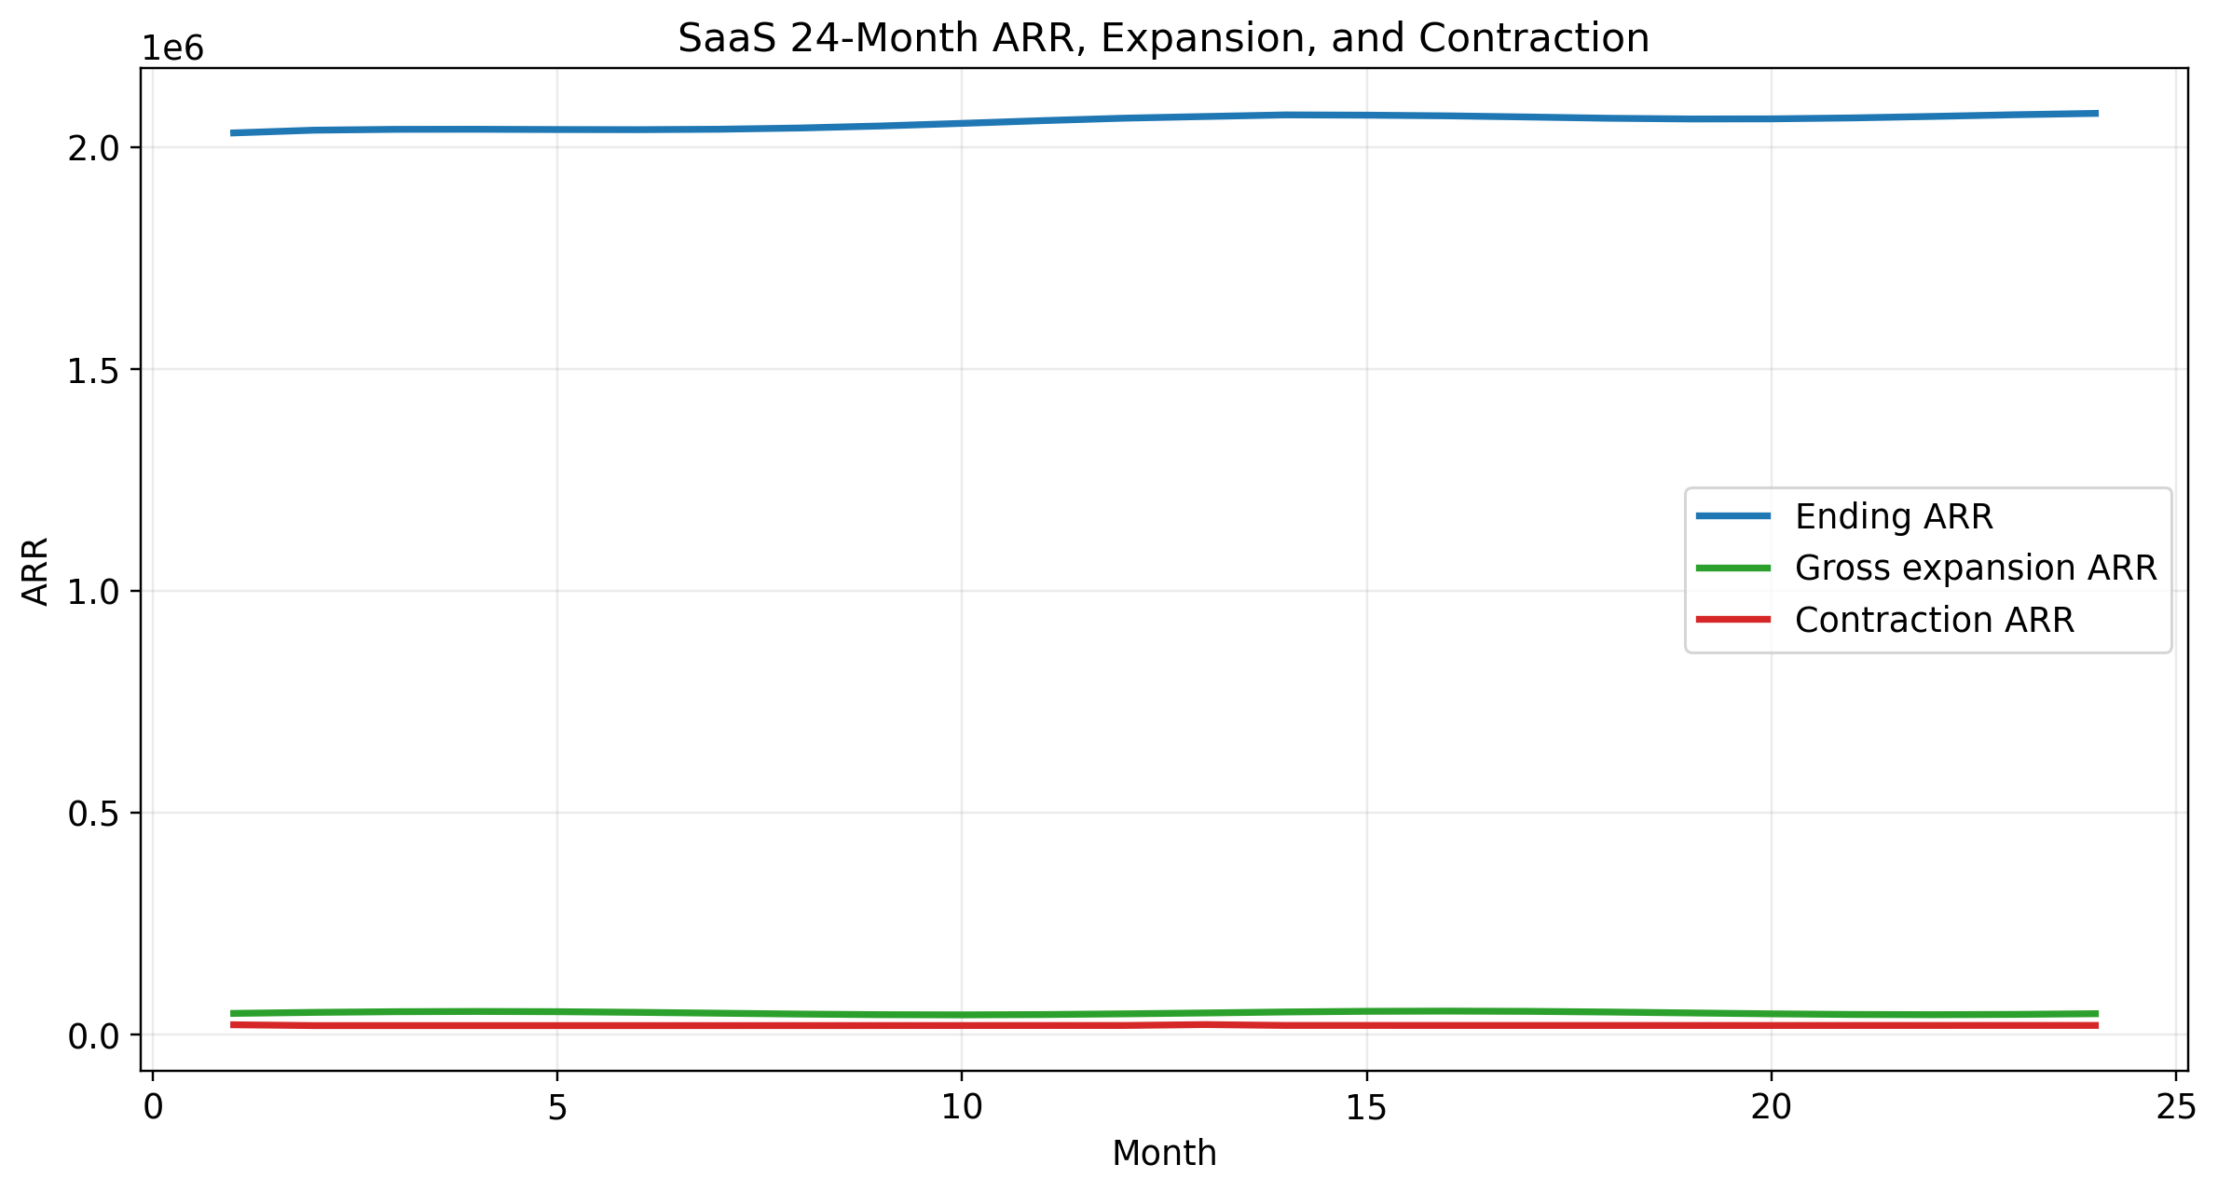
Figure 1. SaaS ending ARR with gross expansion and contraction components.
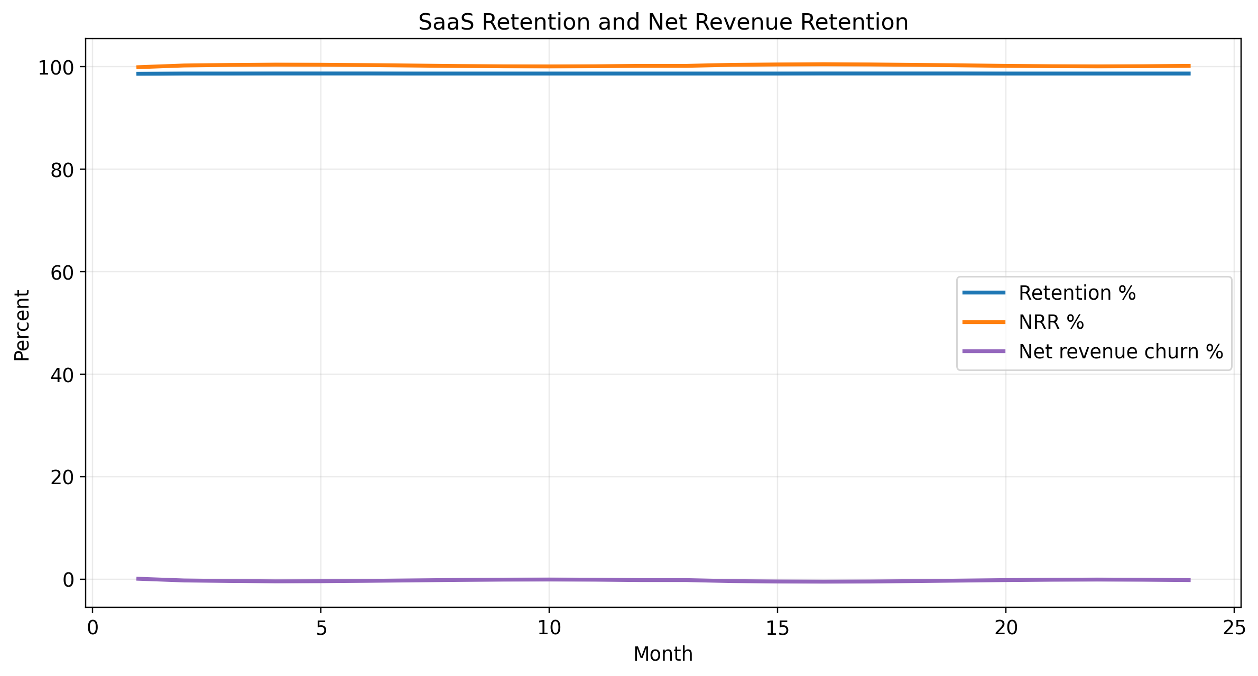
Figure 2. SaaS retention, NRR, and net revenue churn over 24 months.
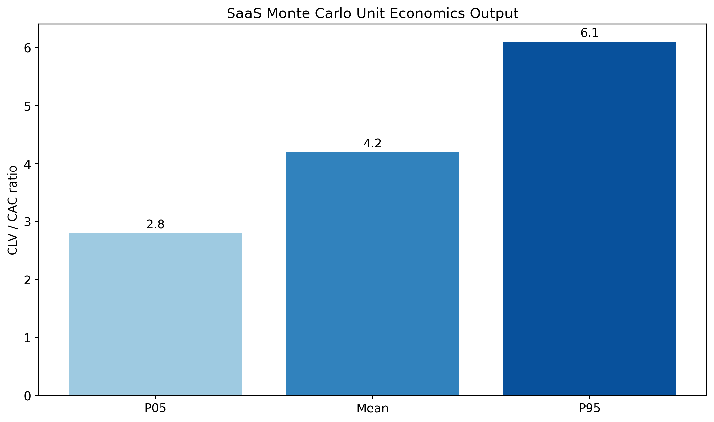
Figure 3. Monte Carlo unit-economics output range for CLV/CAC.

Transparency, Assumptions, Limitations, and Confidence
- The model is benchmark-calibrated, not company-specific. It is strongest as a planning and communication framework.
- The $1M-$3M ARR band was selected intentionally as the SaaS archetype and should be preserved when interpreting absolute outputs.
- Forecast quality declines further out in the 24-month horizon, particularly after month 12.
- Confidence score 78/100 is a realism score for structure and documentation, not a statistical certainty claim.
- Licenses were retained only where the terminology is directly interpretable in SaaS; generic seat logic was removed.

Appendices
Appendix A: Data sources are listed above. Appendix B: Detailed monthly outputs are in the Excel workbook. Appendix C: All 17 audit fixes are cross-referenced in the updated audit response document. Appendix D: The dashboard and assumptions sheets in the workbook provide the executive quick-reference view.

